Name : Abdul Rehman Section :B

Course : CCN Roll No : CT-22052

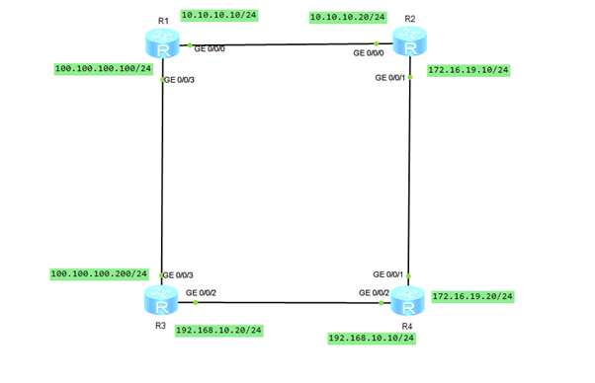

**R1**

system-view

interface GigabitEthernet 0/0/0

ip address 10.10.10.10 255.255.255.0

quit

interface GigabitEthernet 0/0/3

ip address 100.100.100.100 255.255.255.0

quit

ip route-static 172.16.19.0 255.255.255.0 10.10.10.20

ip route-static 192.168.10.0 255.255.255.0 100.100.100.200

**R2**

system-view

interface GigabitEthernet 0/0/0

ip address 10.10.10.20 255.255.255.0

quit

interface GigabitEthernet 0/0/1

ip address 172.16.19.10 255.255.255.0

quit

ip route-static 100.100.100.0 255.255.255.0 10.10.10.10

ip route-static 192.168.10.0 255.255.255.0 172.16.19.20

**R3**

system-view

interface GigabitEthernet 0/0/3

ip address 100.100.100.200 255.255.255.0

quit

interface GigabitEthernet 0/0/2

ip address 192.168.10.20 255.255.255.0

quit

ip route-static 10.10.10.0 255.255.255.0 100.100.100.100

ip route-static 172.16.19.0 255.255.255.0 192.168.10.10

**R4**

system-view

interface GigabitEthernet 0/0/1

ip address 172.16.19.20 255.255.255.0

quit

interface GigabitEthernet 0/0/2

ip address 192.168.10.10 255.255.255.0

quit

ip route-static 10.10.10.0 255.255.255.0 172.16.19.10

ip route-static 100.100.100.0 255.255.255.0 192.168.10.20

